Park and Stormwater Sales Tax Fund
Project Name:  Smith’s Fork Park Complex | Department:  Parks & Recreation
Type of Project:  Improvement and Rehabilitation | Contact:  Matt Denton
Estimated Project Cost:
$2,880,000
Description:
As part of the Parks and Recreation Master Plan, Smith’s Fork Park was identified as a comprehensive recreational asset and Heritage Park was seen as an extension of Downtown Smithville for community and social events. To make this vision a reality, the ballfields at Heritage Park would need to be relocated to Smith’s Fork Park (please see the map below). This would make Smith’s Fork Park a destination recreation area and allow Heritage Park to be an extension of downtown.
The Smith’s Fork Park 4-plex ball field design would create a more effective use of the property and put all ball fields together in one space. This project is planned to be funded by the Parks and Stormwater Sales Tax and potential Land Water Conservation Fund grants. Staff has been working with the City’s Finance Department to save up $300,000 year over year to fund the project.
Justification:
The map below shows the relocation of the 4-plex ball fields at Smith’s Fork Park.
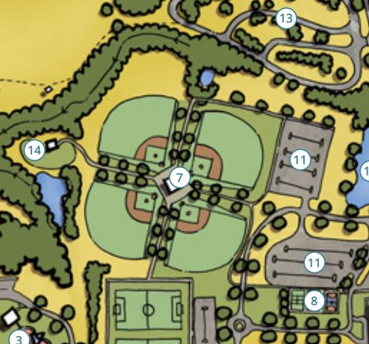

Impact on operating Costs
This project will have a large impact on operations cost. It is expected that the number of visitors will increase therefore additional Park Maintenance staffing will be necessary. This is to ensure the area and the fields remain in well-kept and clean conditions.

Estimated Expenditures
 | FY2026 | FY2027 | FY2028 | Total
Engineering | $320,000 | $320,000 | - | $640,000
Construction | - | - | $2,240,000 | $2,240,000
Total | $320,000 | $320,000 | $2,240,000 | $2,880,000

Funding Sources
 | FY2026 | FY2027 | FY2028 | Total
Parks & Stormwater Sales Tax | $320,000 | $320,000 | $2,240,000 | $2,880,000
Total Net Cost | $320,000 | $320,000 | $2,240,000 | $2,880,000

